Economics of Electricity Pricing
Energy is one of the world’s most important commodities. As the global society continues to grow technologically, the need for efficiency in the sale and purchase of electricity must be constantly improved. As a commodity, electricity is homogeneous – that is, there is no “good” or “bad” electricity – the product is constant in its nature and quality. Electricity is also a secondary product, which means that it is a derivative of primary energy sources such as gas, coal, and solar power. The supply and demand of electricity is affected by a number of factors, including location, season, temperature, and technology. Combined with the markets for the aforementioned primary energy sources, these factors largely impact the economics of electricity.

In a given region, electricity is supplied by conventional generators, such as gas and coal plants, and renewable generators, like solar and wind farms. For the sake of simplicity, this paper will describe the theoretical supply curve for a gas plant, which burns fuel to generate power. One measure to convey the efficiency of fuel-burning plants is heat rate, which is the amount of energy used by a power plant to generate one kilowatt-hour (kWh) of electricity. Figure 1 shows an example of an incremental heat curve for a conventional generator, which defines incremental heat rate at different production levels (megawatt/MW) of a plant.
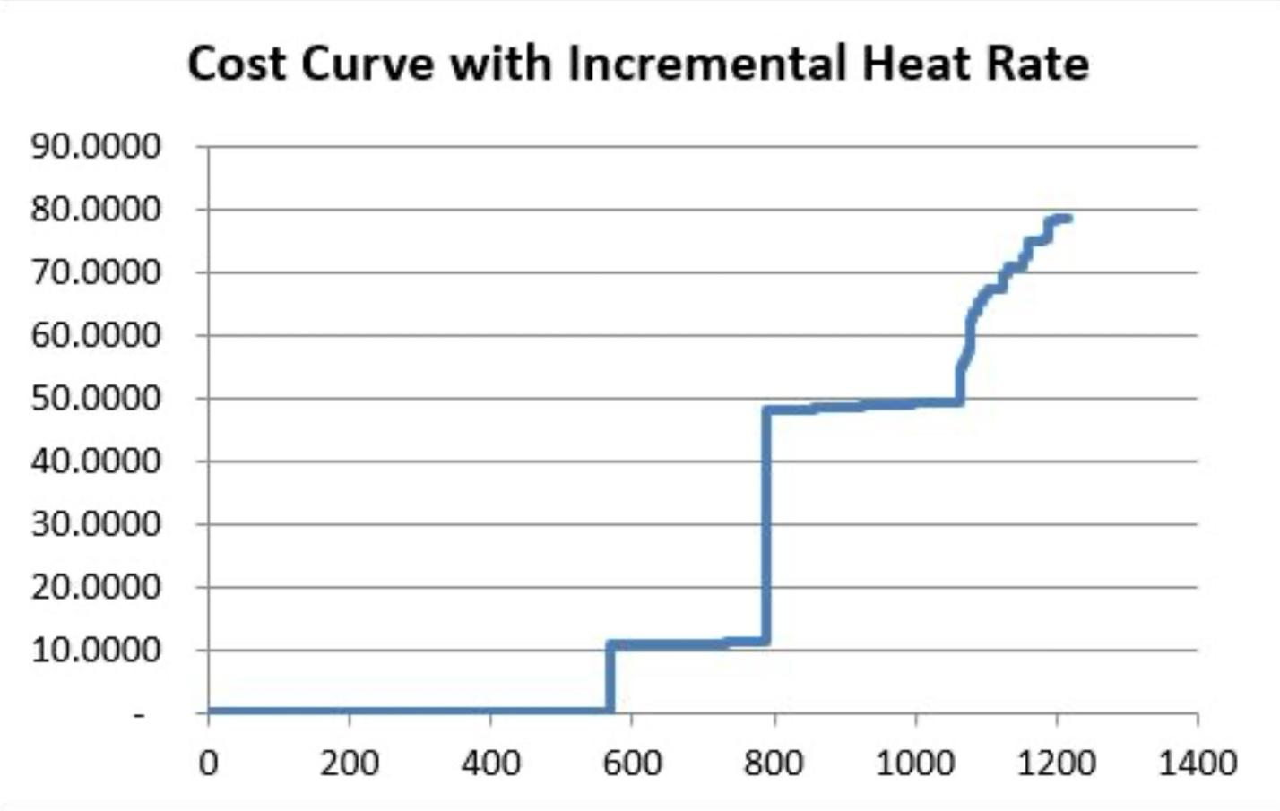Figure 1: Example marginal heat rate curve (capacity in MW on x-axis, cost in $ on y-axis)
Since fuel is the main cost for such a generator, this graph can be directly interpreted as a marginal cost curve for producing electricity. In turn, the supply curve (Figure 2) for this region’s market is made up of all of its generators’ marginal cost curves. At the lower end of the supply curve are renewable generators, as their marginal cost of operation is very low; on the other end, the high costs of operating an oil-fired generator make the production of electricity through oil more expensive. This supply curve is typically referred to as a “hockey stick curve” – as generation increases, the incremental cost of electricity climbs at a growing rate.

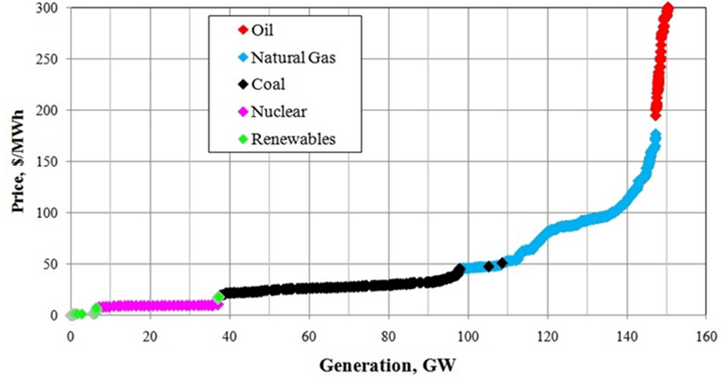
Figure 2: Typical PJM (eastern US electric wholesaler) supply stack

In the market for electricity, the total demand is typically made up of the demand from residential, commercial, and industrial sectors, all of which are overseen by local utilities such as SRP and APS. These utilities buy electricity directly from the market and distribute it according to their region’s demand. The market demand is plotted as the amount of electricity needed over a specific period of time. The demand curve for these wholesale buyers is relatively inelastic, as the demand for electricity typically doesn’t change due to changes in price. Additionally, each sector has a slightly different demand curve, as an industrial building may use more electricity than a residential property at certain times, and vice versa. The demand for electricity also depends on multiple factors, such as time of day, temperature, location, and season. In Figure 3, the peaks of the graph represent the daytime hours, during which electricity use is the highest. Additionally, the red line, which shows the demand for July 2009, consistently has the highest peaks, as more electricity is typically used in the summer months for air conditioning. Demand is also lower between hours 120 and 168, which signify the break from school and work over the weekend.

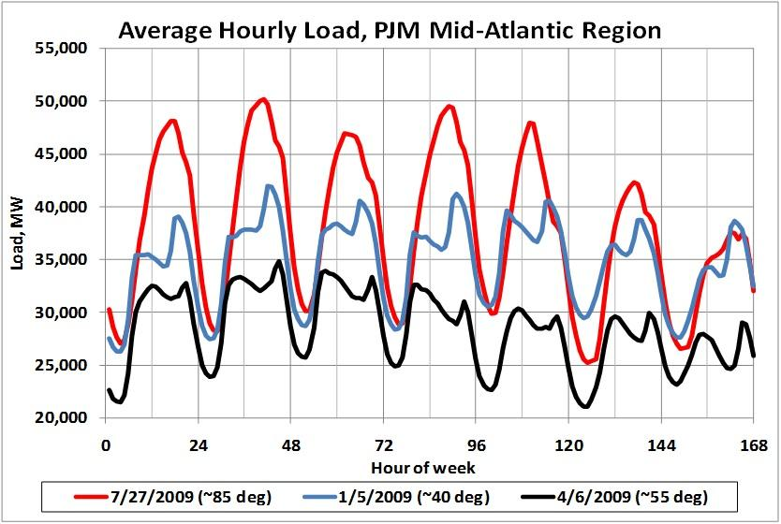
Figure 3: Average hourly load, PJM Mid-Atlantic Region

Much like any other commodity, the price of electricity is calculated by finding the intersection of the supply and demand curves. Additionally, demand is shown as a vertical line because of the assumed instant transfer of electricity. For example, when a light switch is flipped, the electricity required for the light to turn on is expected to be delivered immediately. The intersection point depends on the load, or quantity of electricity demanded. At a load of 90 gigawatts demanded, the supply curve says that the price of each megawatt-hour is about $35. If the demand for electricity is increased to 145 GW, perhaps due to an increase in the number of office buildings in an area, the price of each unit also increases to around $150 per megawatt-hour. The utilities pay these prices to the generators and pass them along to their customers through fixed rates.

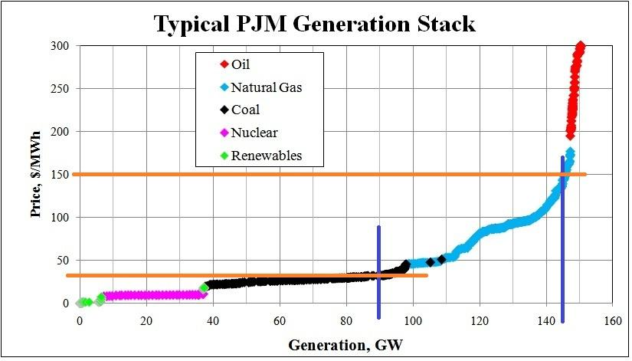
Figure 4: Typical PJM generation stack

In the real world, the market is split into many smaller groups. This is due to the limitations on the capability of transmission lines to quickly and reliably transport electricity to keep up with demand. Locational marginal pricing (LMP) is a concept that is based on the differing marginal pricing of electricity in different locations. This is a large part of why the price of electricity varies with location.

The market for electricity is a volatile one, in which prices tend to fluctuate based on daily, monthly, and even yearly usage. However, as seen in the graphs above, the market can be somewhat predictable if the correct trends are studied. In the short run, the cost minimization problem must be approached knowing that no more generators can be built in a short period of time. So, in the short run, each generator should optimize production for the entire market to be cost-minimized. In the long run, however, new plants can be built to generate more electricity. Thus, the long run market optimization involves optimal production as well as proper investment in new generators. As renewable energy sources become more prevalent, now is a better time than ever to reconsider how exactly the market for electricity can be optimized in the future.

Works Cited

A. Kumar David and Fushuan Wen, "Market power in electricity supply," in IEEE Transactions on Energy Conversion, vol. 16, no. 4, pp. 352-360, Dec. 2001, doi: 10.1109/60.969475.

Cramton, P. (2017). Electricity market design. Oxford Review of Economic Policy, 33(4), 589–612. https://www.jstor.org/stable/48539475

Customized yet Standardized Temperature Derivatives: A Non-Parametric Approach with Suitable Basis Selection for Ensuring Robustness - Scientific Figure on ResearchGate.
Daily Energy Demand Curve. energymag. (2014, February 17). https://energymag.net/daily-energy-demand-curve/
Day-Ahead Residential Electricity Demand Response Model Based on Deep Neural Networks for Peak Demand Reduction in the Jordanian Power Sector - Scientific Figure on ResearchGate.
Erdmann, G. (n.d.). Economics of electricity - EPJ web of conferences. EPJ. https://www.epj-conferences.org/articles/epjconf/pdf/2015/17/epjconf_eps-sif_06001.pdf
Generator Economic Curves. Generator economic curves. (n.d.-d). https://www.powerworld.com/WebHelp/Content/MainDocumentation_HTML/Generator_Economic_Curves.htm
Short-term marginal cost presentation and analysis – Edward Bodmer ... (n.d.). https://edbodmer.com/short-term-marginal-cost-presentation/
Supply and demand of electricity - stockholm school of ... (n.d.-b). http://arc.hhs.se/download.aspx?MediumId=1196
The fundamentals of Electricity Markets. The Fundamentals of Electricity Markets | E B F 200: Introduction to Energy and Earth Sciences Economics. (n.d.). https://www.e-education.psu.edu/ebf200/node/151
4. the price and value of electricity. Open Electricity Economics: 4. (n.d.). http://open-electricity-economics.org/book/text/04.html#:~:text=Key%20point%3A%20Prices%20are%20determined,intersection%20of%20demand%20and%20supply.&text=Fluctuating%20load.,due%20human%20activity%20and%20needs.

